James J. Kim

Mrs. Conner

Principal

Eisenhower Elementary School

277 Rondonovan Dr.

Santa Clara, CA 95051

Dear Mrs. Conner:

As you are already aware, childhood obesity is a nationwide epidemic that affects millions of children throughout our country. One of the root-cause of childhood obesity is public school lunch program, and it's affecting our students here at Eisenhower Elementary School. There have been numerous studies conducted by Centers for Disease Control to understand the problem, and Congress has even attempted to solve this epidemic by introducing several fundamental changes to the lunch program. The proposed solutions have made no significant impact, and all the students are still affected each day. In 2010 the Journal of School Health, the author Ji Li revealed some startling statistics that children attending a public school that participates in National Public Lunch Program have a 4.5% probability of being overweight. Furthermore, children have higher BMI than those attending private school. (Journal of School Health, 2010) We need change, and you can help to make a difference. A simple switch in the lunch menu can have a significant positive impact on our kid's health. We need to take immediate actions to remove flavored from the lunch program and find a healthier alternative.

Any attempt to solve childhood obesity is a monumental task, and we're undoubtedly not trying to resolve this issue here. However, what we are attempting is to make a small change that will have a lasting impact on our kid's health. A program like Healthy Hunger-Free Kids Act strives to provide healthy and balanced meals. The daily lunch program incorporates whole grain meals, fruits, and choice of beverages. As described in the U.S. News article in 2016, part of the original program requires that kids are offered two types of drinks: fat-free milk and 1 percent milk. And flavored milk is also permitted as long as it's fat-free. (U.S. News 2016) This mandate was put in place to provide options for our kids. The students will have an option of choosing a fat-free or 1 percent flavored milk. What is not apparent is the content of the flavored milk which can contain up to 20 grams of sugar. To put this number into perspective, a single can of Coca-Cola contains 39 grams of sugar. If a student consumes all the available meals at school, they would be drinking roughly 40 grams of sugar per day. That is ten teaspoons of sugar. The most logical way to approach this issue is by eliminating the flavored milk from the menu. Although this may seem like a stopgap measure, it is the most feasible way to handle this problem until a permanent solution can be put in place.

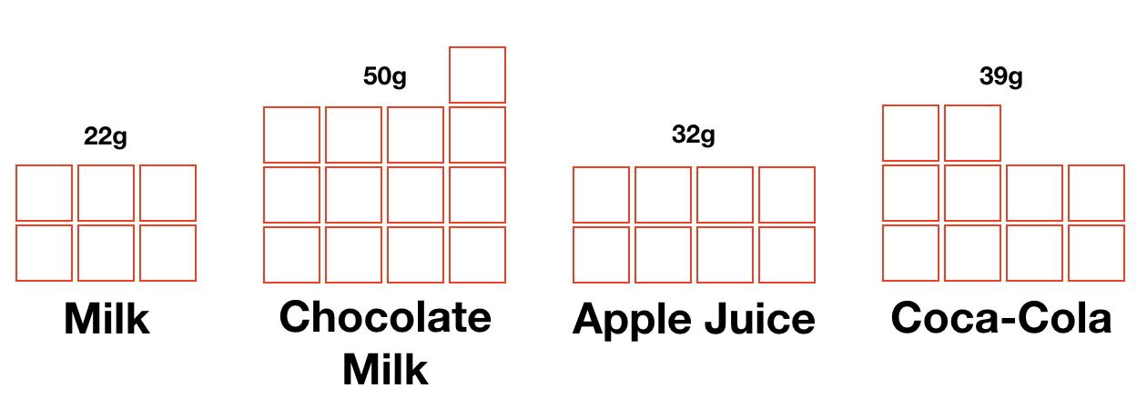

In a district in Georgia, concerned parents and PTA decided to overhaul their lunch program to provide healthier meals for their students. The new program introduced whole-grain foods and fresh fruits as an alternative which increased fruit and veggie consumption by 40%. (Time 2012) In the same TIME magazine article, the author also states "schools also eliminated sugary beverages from their vending machines and replaced them with water and 100% juice drinks. (Time, 2012)” Although this didn't eliminate all the sugary beverages from the school campus, it did restrict access by removing sodas from the vending machines.

Some may argue that we should let the government manage the lunch program. But the truth is it hasn't worked. We currently do have a national lunch program and the program is designed to provide healthy and balanced meals for our kids at school, but it is politicized and doesn't provide the necessary restriction to protect the kids. The meal guideline recommends availability of different types of milk to school but as mentioned in the U.S. News article, "powerful dairy lobby to mandate higher consumption of milk in schools and to promote flavored milk as a way to do so, which of course would add more sugar into school meals. (U.S. News A World Report 2016)"

It is clear that this issue affects us at Eisenhower Elementary School. Childhood obesity is on the rise, and it is critical that we take immediate steps to address the problems. In an article published by U.S. News World Report, the writer Ann Cooper reports "the Centers for Disease Control and Prevention has reported that 17 to 30 percent of children ages 2 to 19 are overweight or obese. (U.S. News A World Report 2016)" Reducing the amount sugar intake and eliminating excess calories can drastically help to prevent childhood obesity.

It is time to step in and make the right decision that will help shape the lives of all the students at Eisenhower Elementary School. The removal of sugar-packed beverages from the lunch menu will not only help all the students, but it will start the beginning of their new healthy lifestyle.

Sincerely,

James J. Kim

References

Auge Karen (2009) The Denver Post [Photograph]  
<http://www.denverpost.com/2009/11/29/colorado-schools-face-cartons-of-controversy-over-milk/>

Cooper Ann (2016) U.S. News  
<https://health.usnews.com/health-news/blogs/eat-run/articles/2016-03-25/snack-crack-our-childrens-addiction-to-sugar>

Julie Kelly, Jeff Stier (2015) *The School Lunch Program With an Unappetizing Report Card* <https://search-proquest-com.ezproxy1.lib.asu.edu/docview/1689552371?accountid=4485&rfr_id=info:xri%2Fsid:primo>

Keith-Thomas Ayoob. Childhood Obesity. August 2011, 7(4): 271-273.   
<https://doi-org.ezproxy1.lib.asu.edu/10.1089/chi.2011.0400.edit>

Li Ji, Ph.D., Hooker Neil H, Ph.D. (2010) Childhood Obesity and Schools: Evidence From the National Survey of Children's Health  
<http://onlinelibrary.wiley.com.ezproxy1.lib.asu.edu/doi/10.1111/j.1746-1561.2009.00471.x/full>

Robinson Thomas N., MD, MPH ( 2005) Preventing childhood obesity: A solution-oriented research paradigm  
<http://www.sciencedirect.com.ezproxy1.lib.asu.edu/science/article/pii/S0749379704003101>

Sifferlan Alexandra (2012) Time   
<http://healthland.time.com/2012/12/31/more-food-for-hungry-students-usda-tweaks-school-meals/>